Table of Contents

1 Summary 2

2 Context 2

3 Results 2

3.1 Conversion Rate Analysis: 2

3.1.1 Implementation for Conversion Rate Analysis 2

3.2 95% Confidence Interval for Conversion Rate Difference: 2

3.2.1 Implementation for 95% Confidence Interval 3

3.3 Average Amount Spent Analysis: 3

3.3.1 Implementation for Average Amount Spent Analysis: 3

4 Analyzing and extracting the dataset using Beekeeper SQL 4

4.1 A query to find the total number of unique users in the dataset 4

4.2 A query to find the total number of converted A&B users and there spending rate 5

4.3 A query to find the total number of converted IOS users and their converted rate 6

4.4 A query to find the total number of converted Android users and their converted rate 6

5 Analyzing Dataset Using Tableau 7

Recommendation: 8

Table of Figures

[Figure 1 SQL Query for extracting the dataset into one 4](https://d.docs.live.net/28eee339f00425a2/Desktop/beekeper%20sql%20datset/Analysis%20of%20Conversion%20Rate%20and%20Average%20Amount%20Spent%20in%20Two%20Test%20Groups.docx#_Toc142004686)

[Figure 2 Output of the consolidated dataset 4](https://d.docs.live.net/28eee339f00425a2/Desktop/beekeper%20sql%20datset/Analysis%20of%20Conversion%20Rate%20and%20Average%20Amount%20Spent%20in%20Two%20Test%20Groups.docx#_Toc142004687)

[Figure 3 Total user SQL query 5](https://d.docs.live.net/28eee339f00425a2/Desktop/beekeper%20sql%20datset/Analysis%20of%20Conversion%20Rate%20and%20Average%20Amount%20Spent%20in%20Two%20Test%20Groups.docx#_Toc142004688)

[Figure 4 A query to find the total number of converted A&B users and there spending rate 5](https://d.docs.live.net/28eee339f00425a2/Desktop/beekeper%20sql%20datset/Analysis%20of%20Conversion%20Rate%20and%20Average%20Amount%20Spent%20in%20Two%20Test%20Groups.docx#_Toc142004689)

[Figure 5 Output showing A&B users and there avg spending 5](https://d.docs.live.net/28eee339f00425a2/Desktop/beekeper%20sql%20datset/Analysis%20of%20Conversion%20Rate%20and%20Average%20Amount%20Spent%20in%20Two%20Test%20Groups.docx#_Toc142004690)

[Figure 6 A query to find the total number of converted IOS users and their conversion rate 6](https://d.docs.live.net/28eee339f00425a2/Desktop/beekeper%20sql%20datset/Analysis%20of%20Conversion%20Rate%20and%20Average%20Amount%20Spent%20in%20Two%20Test%20Groups.docx#_Toc142004691)

[Figure 7 Output of converted IOS users and their conversion rate 6](https://d.docs.live.net/28eee339f00425a2/Desktop/beekeper%20sql%20datset/Analysis%20of%20Conversion%20Rate%20and%20Average%20Amount%20Spent%20in%20Two%20Test%20Groups.docx#_Toc142004692)

[Figure 8 A query to find the total number of Android users and their conversion rate 6](https://d.docs.live.net/28eee339f00425a2/Desktop/beekeper%20sql%20datset/Analysis%20of%20Conversion%20Rate%20and%20Average%20Amount%20Spent%20in%20Two%20Test%20Groups.docx#_Toc142004693)

[Figure 9 Male & Female Count 7](https://d.docs.live.net/28eee339f00425a2/Desktop/beekeper%20sql%20datset/Analysis%20of%20Conversion%20Rate%20and%20Average%20Amount%20Spent%20in%20Two%20Test%20Groups.docx#_Toc142004694)

[Figure 10 Group A&B Total converted Users 7](https://d.docs.live.net/28eee339f00425a2/Desktop/beekeper%20sql%20datset/Analysis%20of%20Conversion%20Rate%20and%20Average%20Amount%20Spent%20in%20Two%20Test%20Groups.docx#_Toc142004695)

[Figure 11 Avg Spent & conversion rate based on region 8](https://d.docs.live.net/28eee339f00425a2/Desktop/beekeper%20sql%20datset/Analysis%20of%20Conversion%20Rate%20and%20Average%20Amount%20Spent%20in%20Two%20Test%20Groups.docx#_Toc142004696)

# **Analysis of Conversion Rate and Average Amount Spent in Two Test Groups**

## **Mir Mohammed Murtuza**

## **1 Summary**

This analysis examines the performance of two test groups, Group A and Group B, in terms of their conversion rate and average amount spent per user. The data were collected from a total of 48,944 unique users after consolidating three tables (activity, group, users) by SQL into one. The goal is to determine if there are significant differences between the two groups, A and B.

## **2 Context**

The motivation behind this analysis is to evaluate the impact of a new treatment (Group B) with a different banner compared to the control group (Group A). The key metrics under consideration are the conversion rate and the average amount spent per user. The dataset includes information on user demographics such as country and gender, as well as the conversion status and total amount spent for each user.

## **3 Results**

All the analysis part was done in Excel Spreadsheets

3.1 Conversion Rate Analysis: The conversion rate analysis reveals that Group B has a higher conversion rate (4.61%) compared to Group A (3.91%). A hypothesis test was performed, and the resulting p-value (0.00014114) indicates that there is a significant difference in the conversion rates between the two groups. Thus, we reject the null hypothesis, suggesting that the new treatment (Group B) with the different banner has a significantly different conversion rate compared to the control group (Group A).

## 3.1.1 Implementation for Conversion Rate Analysis

Null Hypothesis (H0): There is no difference in the conversion rate between Group A and Group B. H0: pA = pB

Alternative Hypothesis (Ha): There is a difference in the conversion rate between Group A and Group B. Ha: pA ≠ pB.

Assumption for the choices:

Are we working with proportions or means? The analysis deals with conversion rates, which are proportions because they represent the percentage of users who converted out of the total number of users.

We are comparing two samples, Group A and Group B, in an A/B test. It means we want to test if the conversion rates of Group A and Group B are different from each other in any direction (higher or lower). Thus, a two-sided test is appropriate.Top of Form

3.2 95% Confidence Interval for Conversion Rate Difference: The 95% confidence interval for the difference in conversion rates between Group B (treatment) and Group A (control) is approximately 0.34% to 1.05%. This interval provides a range estimate with 95% confidence that Group B's conversion rate is between 0.34% and 1.05% higher than Group A's conversion rate.

## 3.2.1 Implementation for 95% Confidence Interval

Step 1: Calculate Conversion Rates Calculate the conversion rate for each group (Group A and Group B) by dividing the total conversions by the total number of users in each group.

Step 2: Calculate Standard Error

Standard Error = √(pA*(1-pA)/nA + pB*(1-pB)/nB)

Where:

pA = Conversion rate of Group A

nA = Total number of users in Group A

pB = Conversion rate of Group B

nB = Total number of users in Group B

Step 3: Calculate Critical Value For a 95% confidence level, the critical value corresponds to the z-score of approximately 1.96. the function to calculate in excel is NORM.S.INV

Step 4: Calculate Confidence Interval Now, use the sample statistic (the difference in conversion rates between Group B and Group A), the standard error, and the critical value to construct the confidence interval.

Confidence Interval = Sample Statistic ± (Critical Value * Standard Error)

Where:

Sample Statistic = Conversion rate of Group B - Conversion rate of Group A

Critical Value = 1.96 (for a 95% confidence level)

Standard Error = Calculated in Step 2

3.3 Average Amount Spent Analysis: The analysis of the average amount spent per user who were converted shows that Group A has a higher average spending per user ($85.28) compared to Group B ($73.17). A T-test was performed to compare the average amount spent between the two groups, and the resulting p-value (0.004033768) is less than the significance level (α = 0.05). Therefore, we reject the null hypothesis and conclude that there is a statistically significant difference in the average amount spent per user between the converted users of Group A and Group B.

## 3.3.1 Implementation for Average Amount Spent Analysis:

The steps are similar to previous question but the formulas for calculating the standard error, test statistic (T-value), degrees of freedom, and p-value are different for this question compared to the previous one. In the previous question, we were dealing with proportions, and the formulas were specific to the analysis of conversion rates. However, for this question, we are analyzing the average amount spent per user, which involves working with continuous values

Step 1: Calculate Average Amount Spent per User for each group (Group A and Group B). I’ve used AVERAGE function in Excel to calculate the average based on the " Total spent of Only users A" and " Total spent of Only users B " column, just like before.

Step 2: performing T-test = T.TEST (sample1, sample2, tails, type)

sample1: The first sample range ("Total spent of Only users A").

sample2: The second sample range ("Total spent of Only users B").

tails: The number of tails for the test. 2 for a two-tailed test.

type: The type of t-test to be performed. 2 for a two-sample, unequal variance t-test.

## 4 Analyzing and extracting the dataset using Beekeeper SQL

To analyze and extract the dataset using Beekeeper SQL, the first step involved consolidating three tables: activity, groups, and users, into one dataset. The following SQL query was used to achieve this

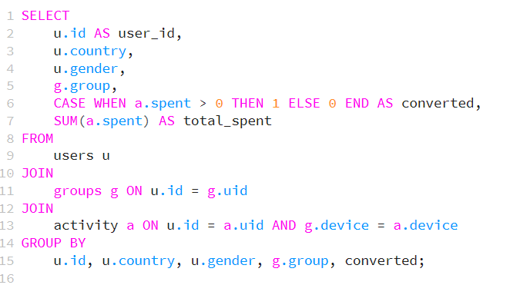

Figure 1 SQL Query for extracting the dataset into one

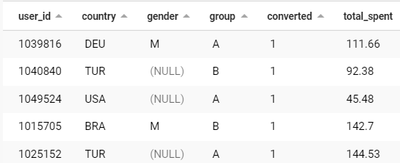

Figure 2 Output of the consolidated dataset

This query combined the relevant information from each table, such as user ID, country, gender, group assignment, conversion status, and total amount spent per user, into a single dataset.

4.1 A query to find the total number of unique users in the dataset:



Figure 3 Total user SQL query

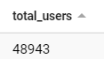

### 4.2 A query to find the total number of converted A&B users and there spending rate

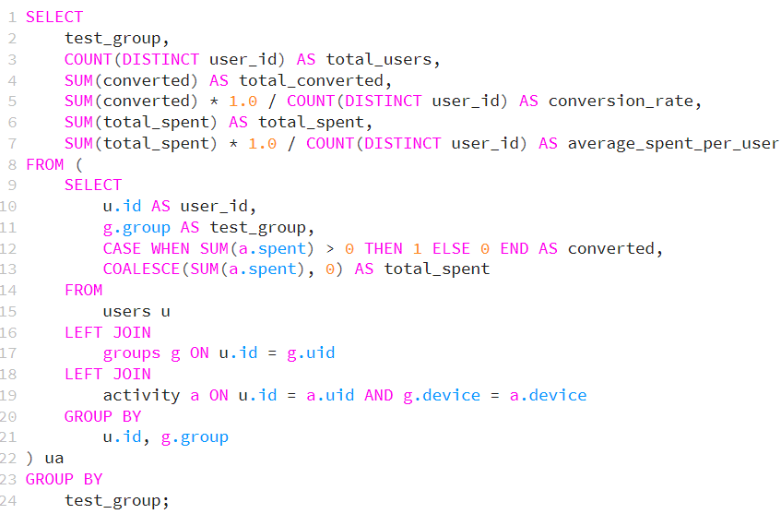

Figure 4 A query to find the total number of converted A&B users and there spending rate

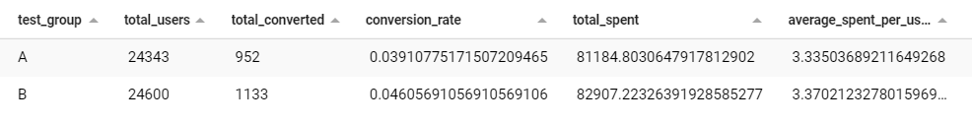

Figure 5 Output showing A&B users and there avg spending

### 4.3 A query to find the total number of converted IOS users and their converted rate

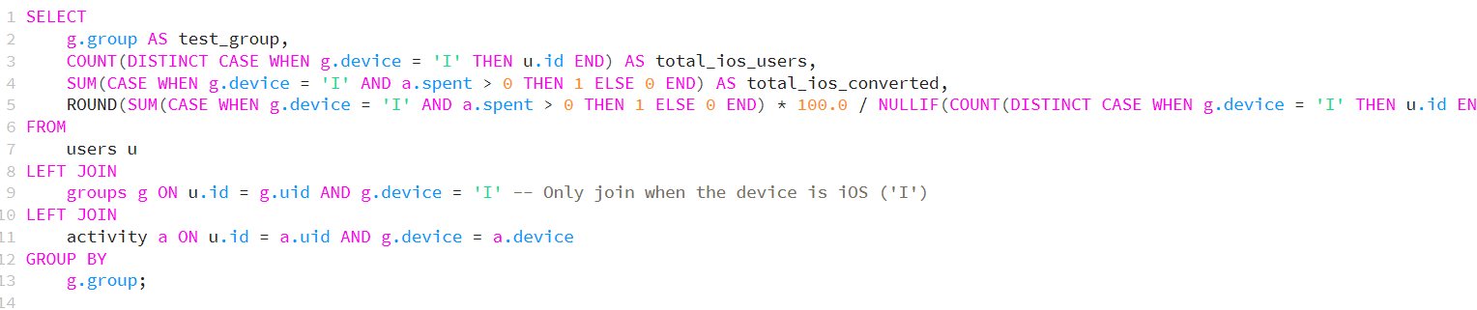

Figure 6 A query to find the total number of converted IOS users and their conversion rate

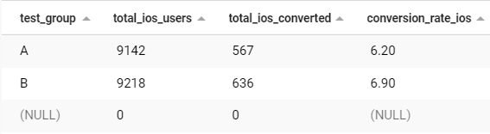

Figure 7 Output of converted IOS users and their conversion rate

### 4.4 A query to find the total number of converted Android users and their converted rate

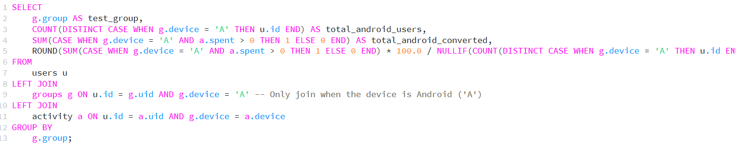

Figure 8 A query to find the total number of Android users and their conversion rate

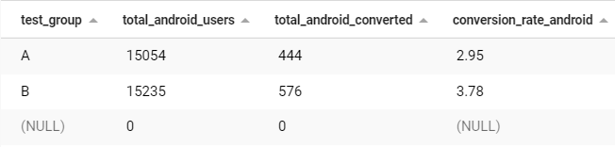

5 Analyzing Dataset Using Tableau

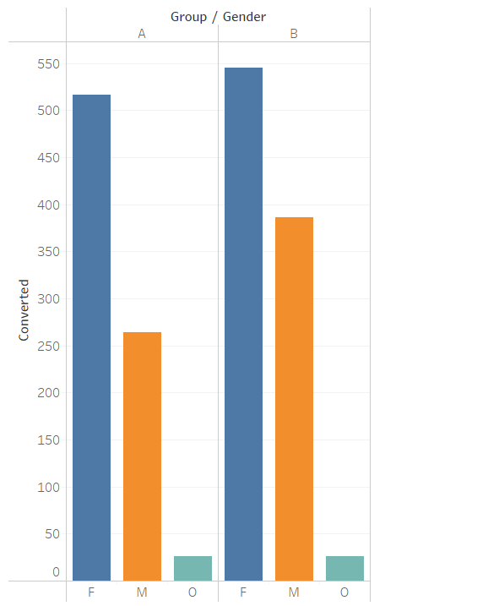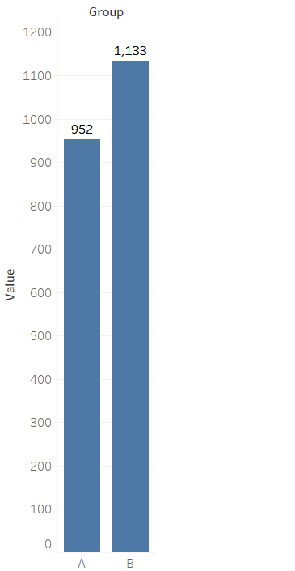

Figure 10 Group A&B Total converted Users

Figure 9 Male & Female Count

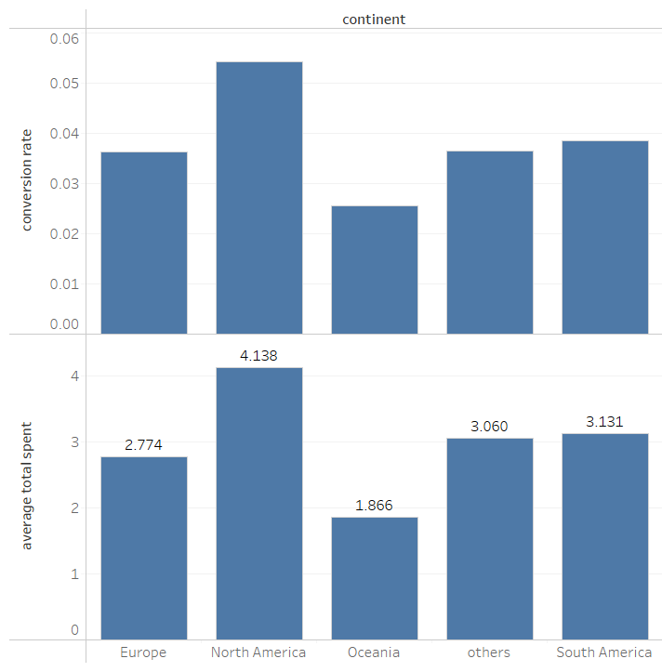

Figure 11 Avg Spent & conversion rate based on region

Recommendation: Based on the analysis, it is evident that the new treatment (Group B) with the different banner has a higher conversion rate than the control group (Group A). Additionally, there is a significant difference in the average amount spent per user between the two groups among the converted users.

Therefore, we recommend launching the new treatment (Group B) as it shows promising results in terms of conversion rate. However, it's important to monitor the average amount spent closely and assess the long-term impact of the changes, however based on the data given we can’t surely say that the converted treatment groups users are buying food & beverage items they may be buying other products. Additionally, further iterations and testing might be beneficial to optimize the user experience and maximize the revenue generated from the users.